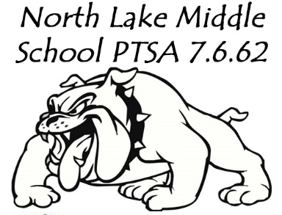
North Lake Middle School (NLMS)
Parent Teacher Student Association (PTSA)
2019-20 School Year Membership Form

Membership is an EASY way to show support for the school. No requirement to volunteer or attend meetings. Your PTSA helps support numerous programs and activities that benefit all of our students. Water bottle filling stations in the gym and cafeteria, Reflections program, Battle of the Books, LAP Family Nights, InvestEd, funding for Science ELL translation/audio equipment, Dogsleds for PE classes and track athletics, funding for Ukulele Club and support for after school clubs, Field Day, Jingle Bell Run and more!
If you have any questions regarding Membership, please contact a PTSA board member (email info on reverse side of this flyer).
Membership Options:
Our PTSA Members get a variety of discounts. Check them out on the WA State and National PTA websites. At North Lake, you get $1 off Spirit Wear and first opportunity to sign up in the student store.
Student Membership ($8) $________
Staff Membership ($8) $________
Individual Membership ($10) $________
Couple Membership ($18) $________
Business Membership ($25) $________
Additional Support:
Gift of STAFF MEMBERSHIP $________ (Specify Staff Member____________________)
Gift of SCHOLARSHIP MEMBERSHIP FUND $________
Gift of GENERAL PTSA DONATION $________
PAYMENT METHOD (circle one) $________ TOTAL AMOUNT
Cash Check (payable to NLMS PTSA) Credit Card
Name on Credit Card: ____________________________________________Billing Zip Code:________________
Card Number:___________________________________CVV #:_______________Exp.Date:________/_________
Member Name(s):__________________________________ __________________________________________
Email Address:____________________________________ __________________________________________
Student Name:____________________________________ Grade: ______
Student Name:____________________________________ Grade: ______
If you are a business interested in supporting NLMS PTSA, please contact Lisa Brittain (northlaketreasurer@gmail.com). In appreciation for your support, your business logo will be proudly displayed listed on our Facebook page and website. The cost is $25.
Return this form to the NLMS office OR join online. www.northlakeptsa.com

Sign Me Up!

